Creating a Custom PEARS Demographics Report
Before You Start
Identify which records should be included in the Demographics report.
(examples: members of a specific club, activity, grade, project, event, etc.)
NOTE: For staff using the 4-H Online Events feature, the same steps can be followed to create a demographics report for your Event.  In Events, click on the Reports tab to create a custom report for that specific event. | 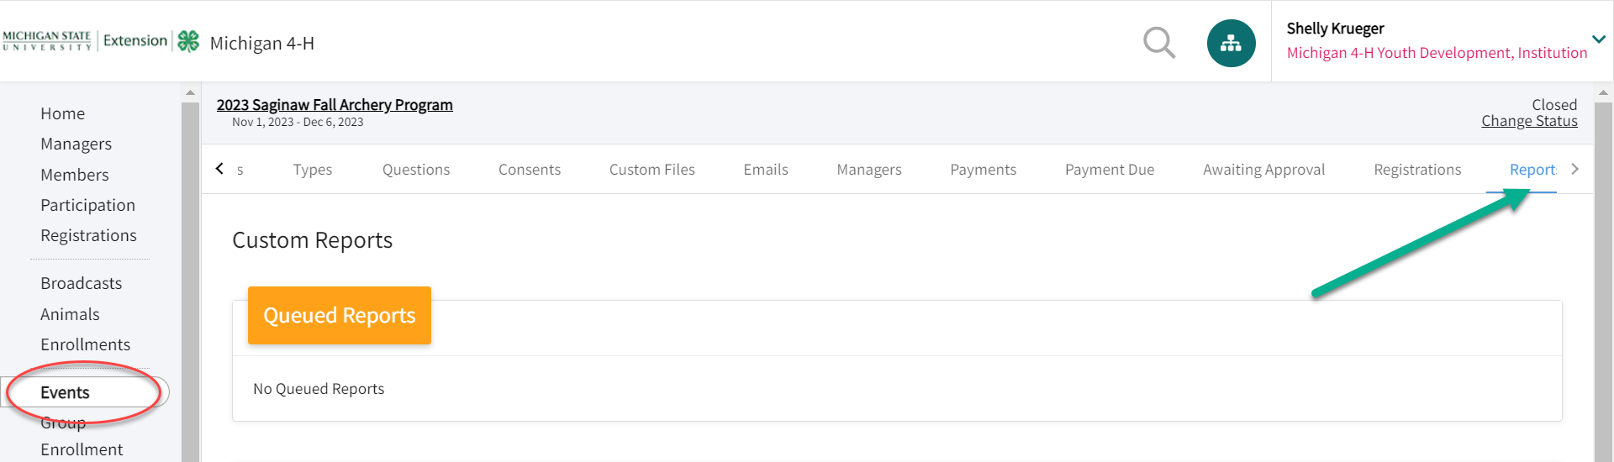
- Click on the Custom Reports tab in the navigation pane.  - Click on the folder title in which you want to add your new report.  - Click Add Report to create a new report in the selected folder. | 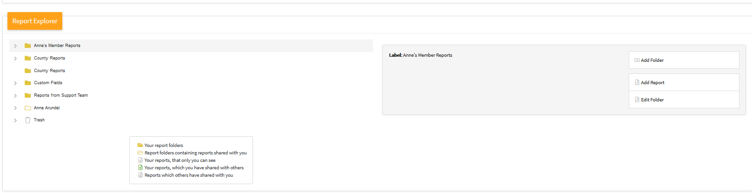
- Enter the name of your report.  - Enter a description of the report.  - Enter the name of the Excel Worksheet title.  - Click the Add button. | 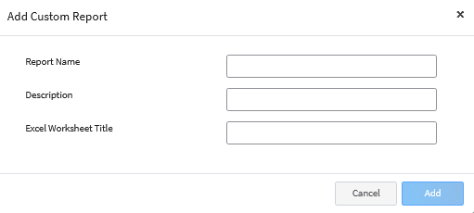
- In the Report Detail section, you may edit the name and description of your report.  (example: Demographics for PEARS) | 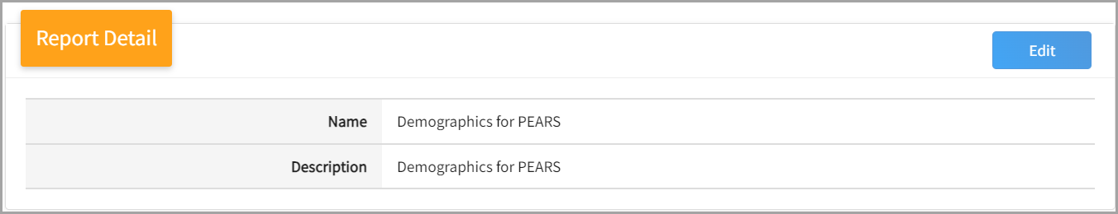
- The Target Data area allows you to set the program year for the report data.  - The Hierarchy drop-down menu allows you to choose the county or area of the hierarchy for the report (within the Manager’s assigned hierarchy areas). | 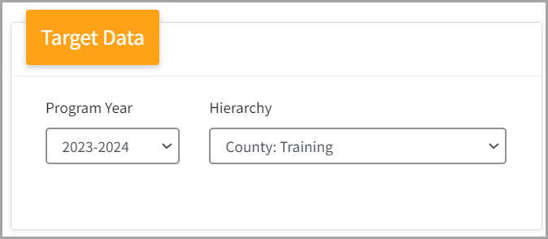
- Click Edit on the Report Columns category to select the columns (fields) to include in the report.  - Click on the Column Category to view the available fields to include in the report. You may select columns from as many column categories as needed.  NOTE: For PEARS demographics, you will use the Member and Participation Column Categories.  - Click on the field name and click the right arrow to add it to the report.  - Repeat steps 12 – 14 for each field you need to add to the report.  - Click Save. | 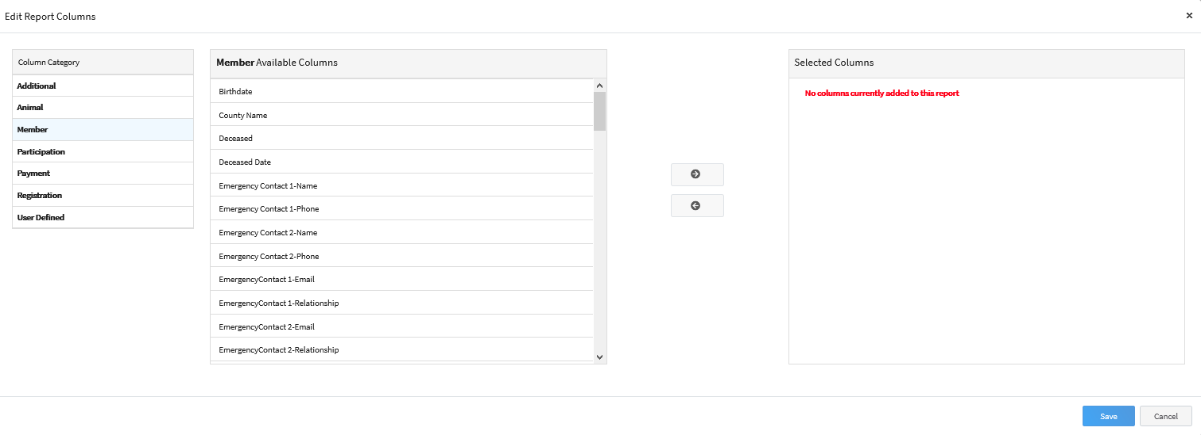  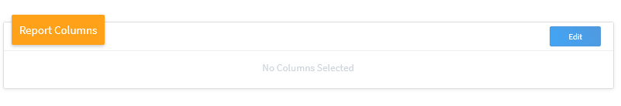
Example of fields to include in a PEARS Demographics Report:  Participation: Enrollment Program Year  Member: Member Id  Participation: Enrollment Role  Participation: Enrollment Status  Participation: Birth Gender  Participation: Identifying Gender  Member: Actual Age  Participation: Program Age  Participation: Racial Breakdown-Ethnicity  Participation: Racial Breakdown-American Indian or Alaskan Native  Participation: Racial Breakdown-Asian  Participation: Racial Breakdown-Black  Participation: Racial Breakdown-Native Hawaiian or Pacific Islander  Participation: Racial Breakdown-White  Participation: Racial Breakdown-Undetermined  Participation: Racial Breakdown-Balance of Other Combinations  Participation: Racial Breakdown-Summary  Participation: Residence  Participation: Residence County  Participation: School Grade  Participation: Military Family Service  Participation: Military Component  Participation: Military Branch | 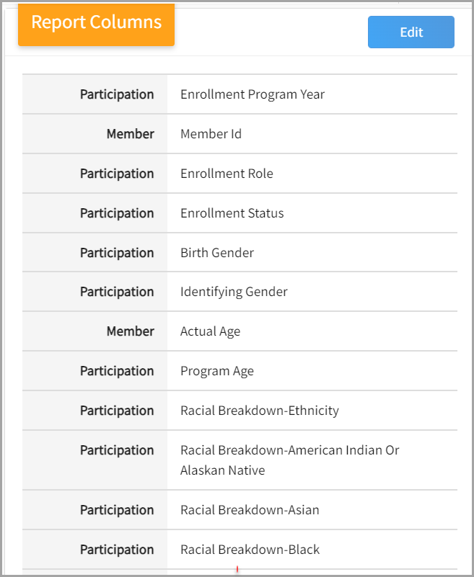
Standard Filters  - Click Edit next to the Standard Filters section to add filters to pull your PEARS demographics.  Example: filter by a specific club, enrollment role, flagged members, school grade, projects, etc.  NOTE: A typical standard filter used for pulling demographics is the Units/Clubs or Members Flagged. | 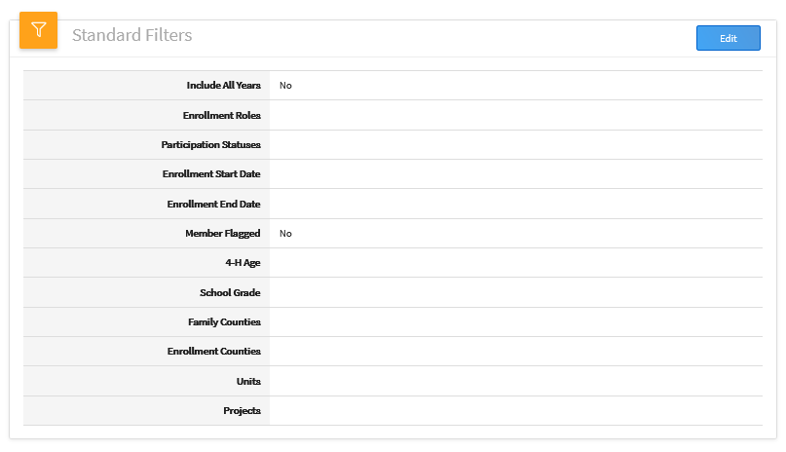
Creating Additional Filters  NOTE: The Custom Filters section can be used to create filters not covered in the Standard Filters section, such as an Activity or Event.  - Add additional filters by clicking Edit next to the Custom Filters section.  - Click the Add Group button.  - Click the Add filter button.  - Select the data field you would like to filter the report on.  The data filter selected in this example is “Activity Name.”  - Select the operator. Depending on the data field you are filtering on, the operator choices may change.  In this case, you would select “Equal Available Options.”  - Select from the available options in the drop-down to filter for.  In this case, you would filter for the “Exploration Days-state event.”  - Once you have entered your custom filter options, click Save.  NOTE: Examples of additional Custom Filters to use would be Activity, Awards, Groups or Event Names. | 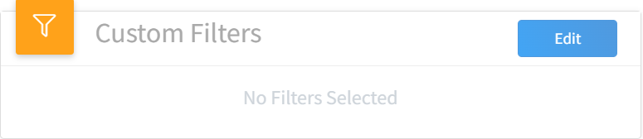  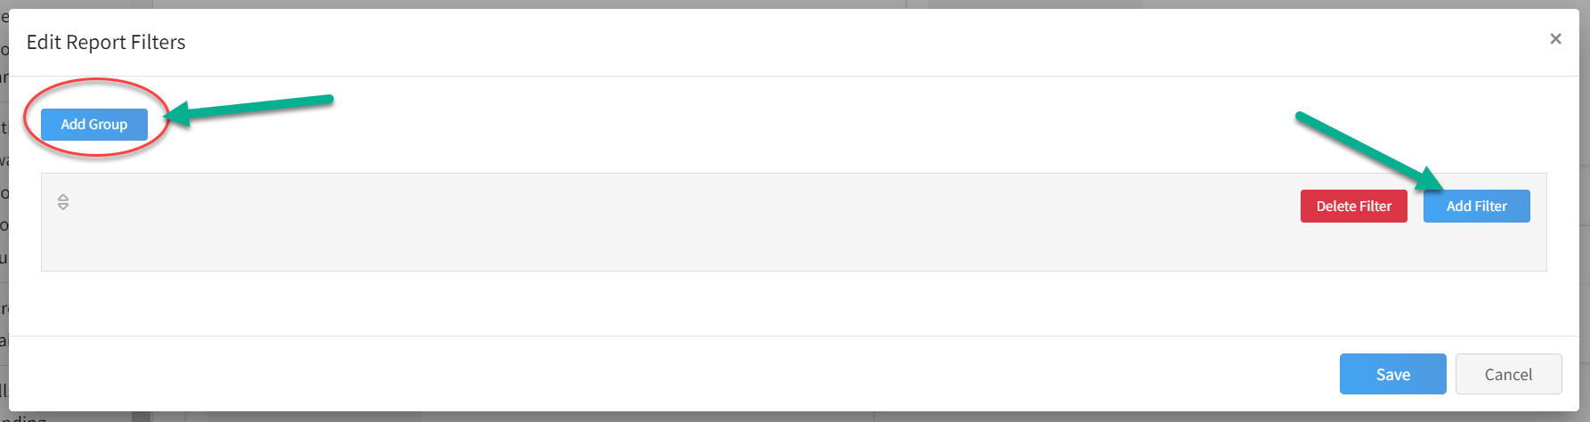  Example:  A custom filter was added for the  “Activity Name”  equals  “Exploration Days-state event”  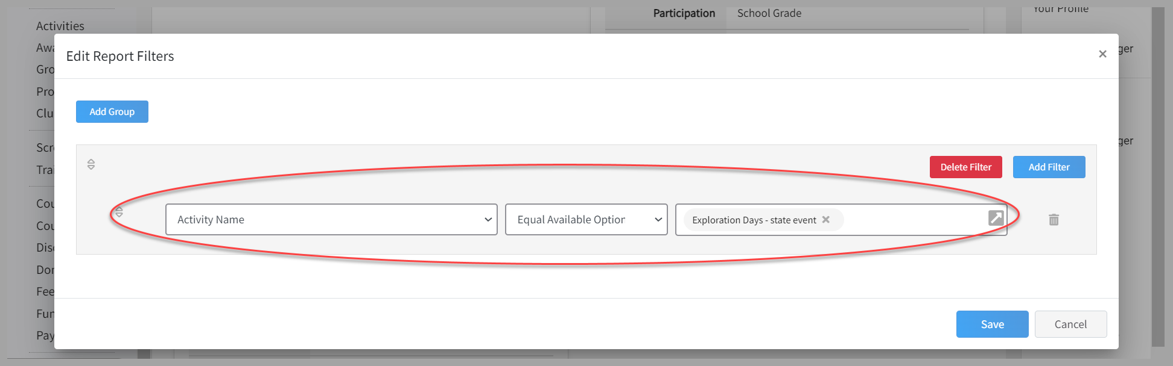  This will pull the demographics for anyone who was added to the Activity  “Exploration Days-state event.”
- Scroll down to the Preview section and click on the Refresh tab. | 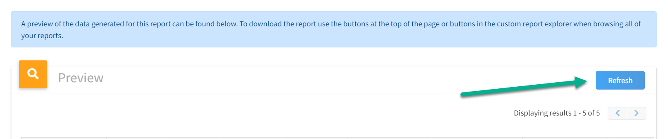
NOTE: Always click on the Refresh tab to update your results with any changes that occur to enrollments.
Demographics Report Results  - Return to the top of the screen to select to download an Excel file.  - Sort Columns to identify or get a count for each demographic needed to report in PEARS. | 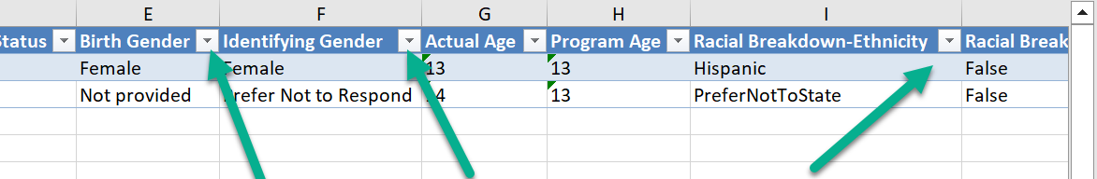  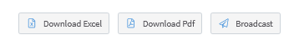
NOTE: The Custom PEARS Demographics Report can be edited at any time. Changes can be made to the standard or custom filters, or edits can be made to the columns and fields that were included in the report. Select the “Edit Report” option. Once in edit mode, you may change your filters to include other clubs, events, activities, etc.
Remember: After saving changes, always click the Refresh option on the report preview to display the newest results.

